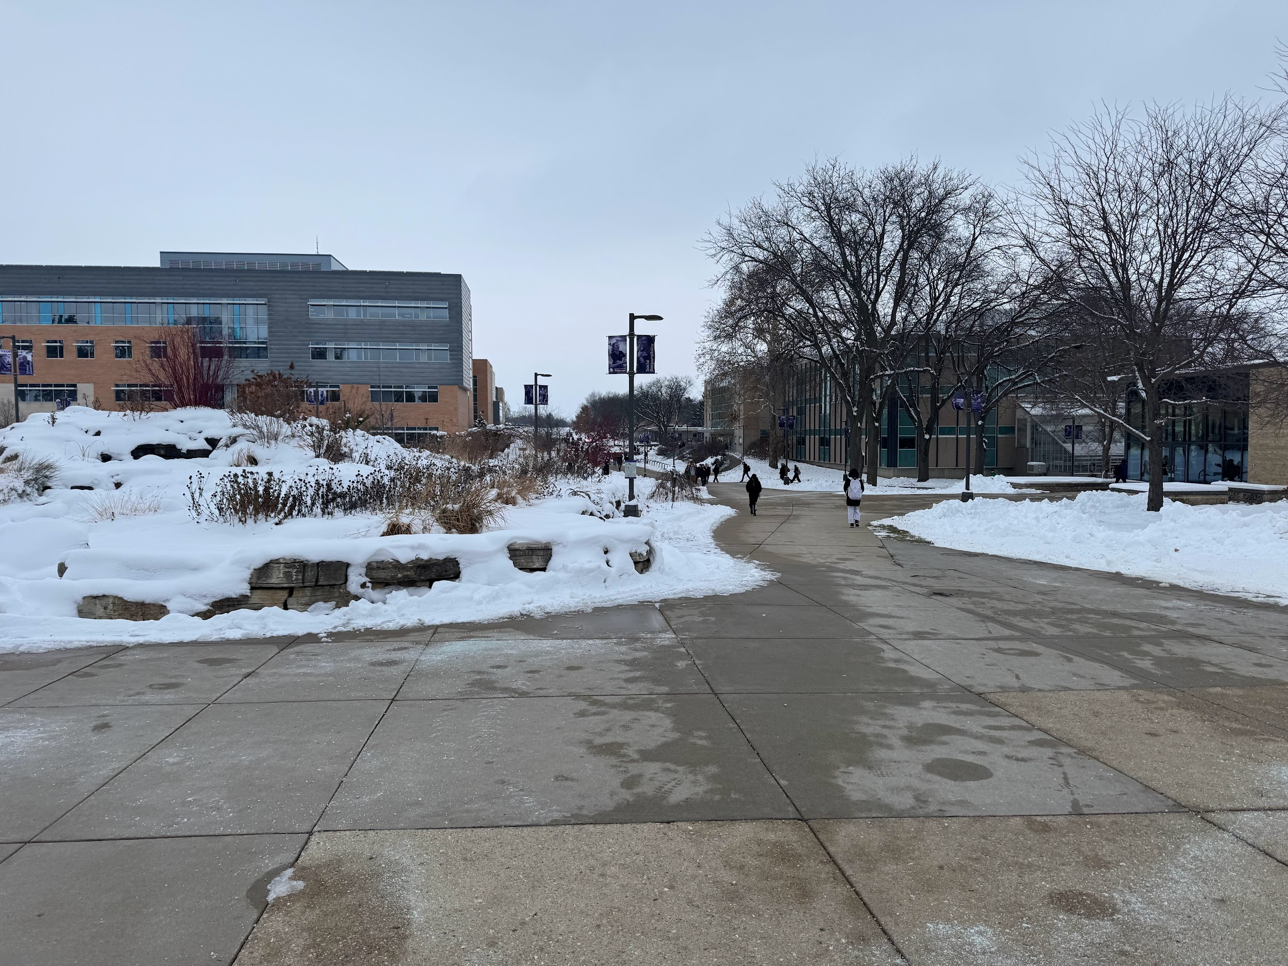

Whitewater Students/Potential Customers walking too and from class

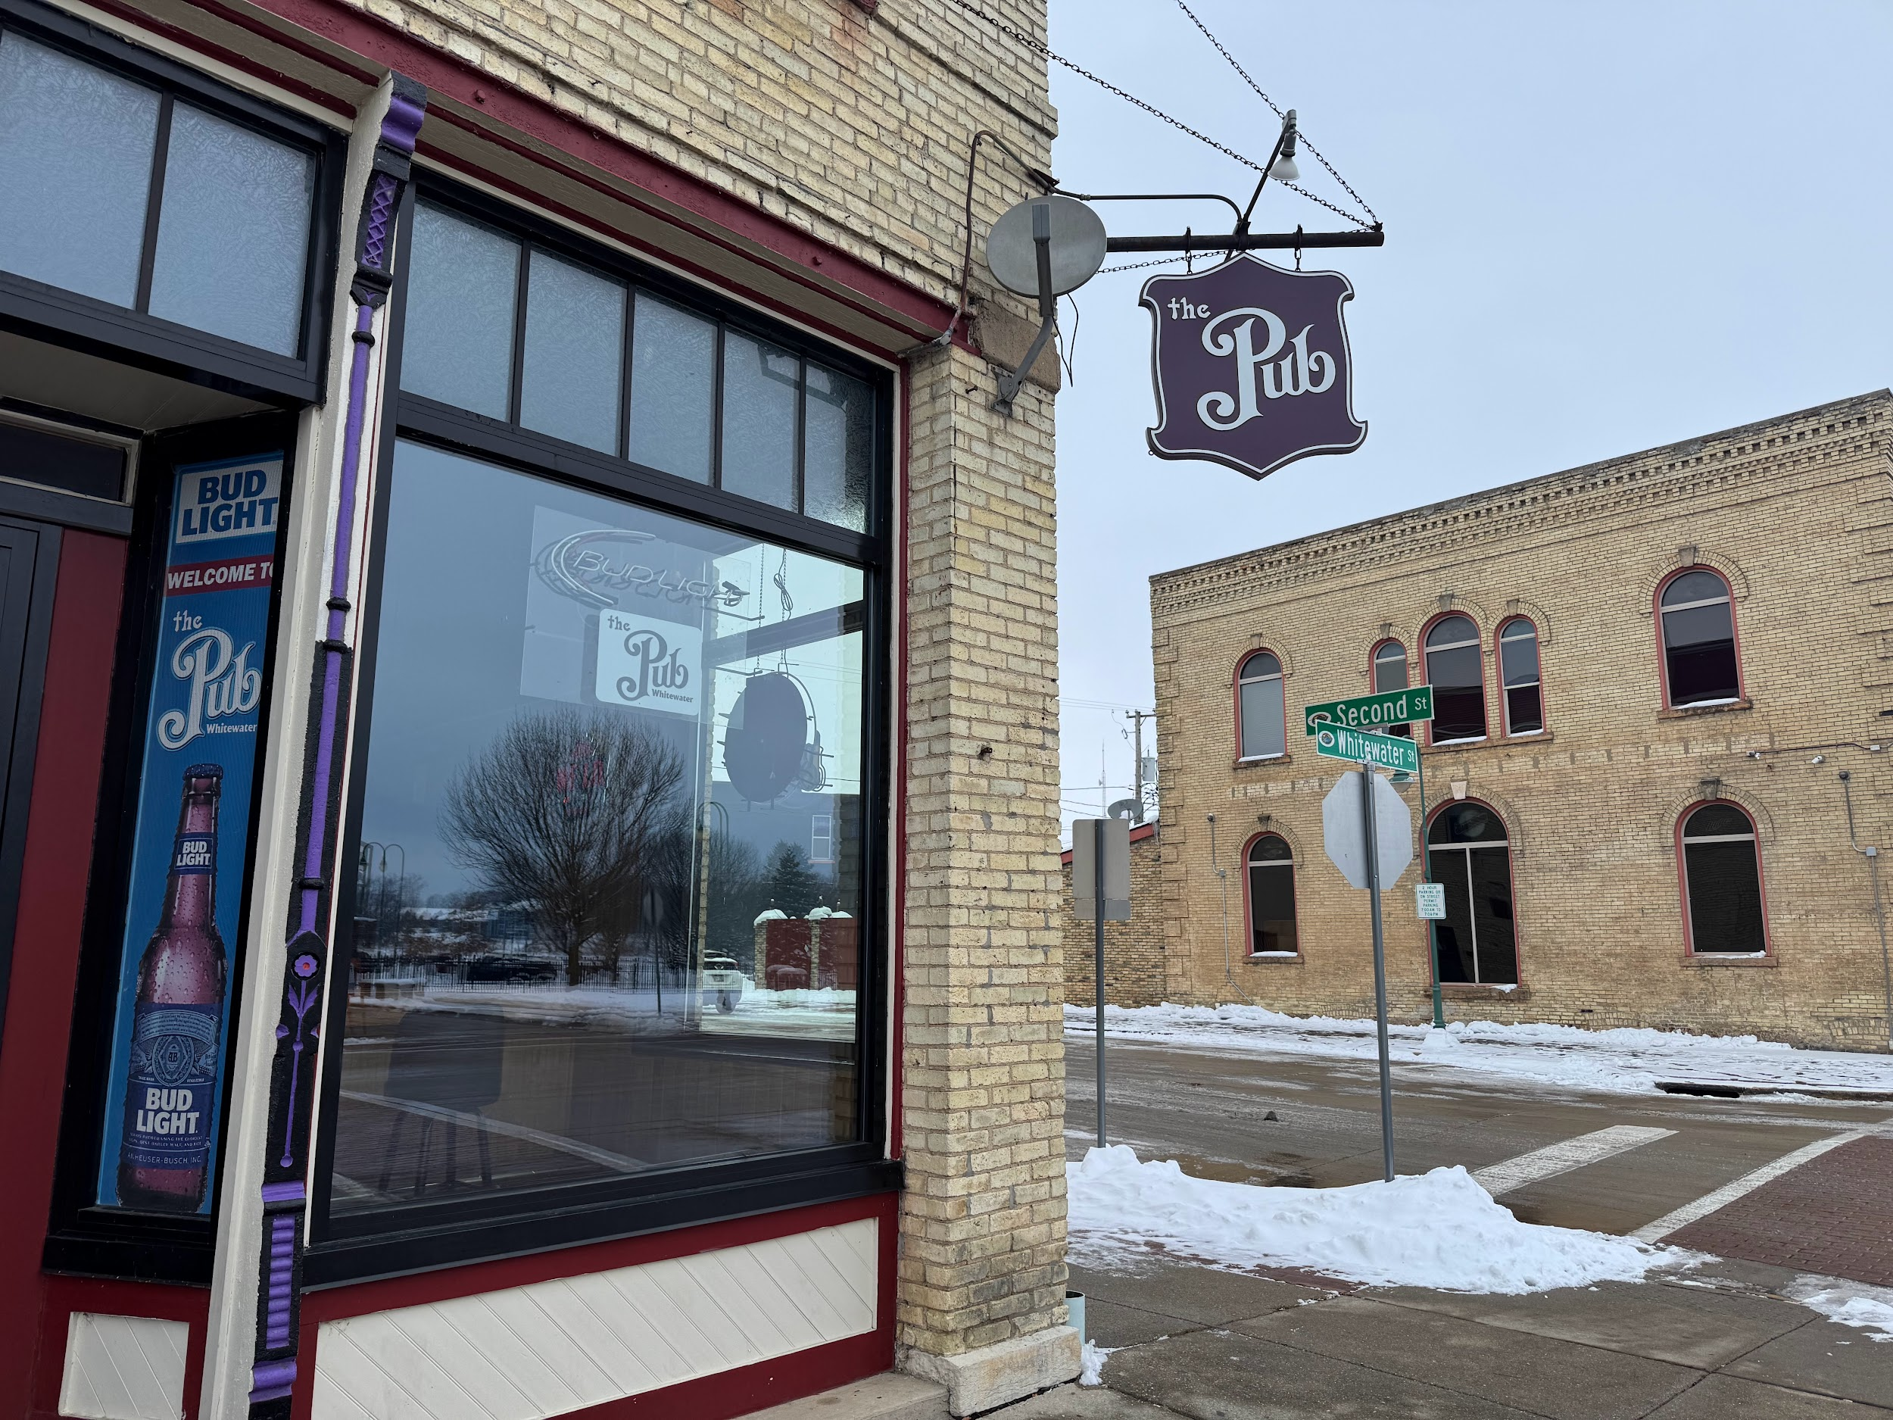

The Pub, one of the many bars located in the downtown district of Whitewater

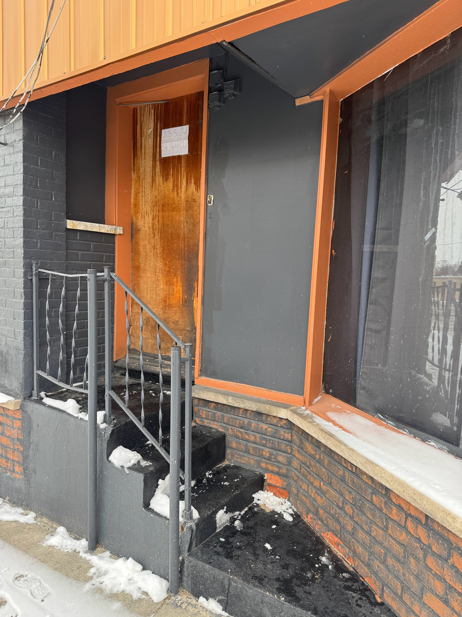

One of the few abandoned work places in the downtown district of Whitewater.

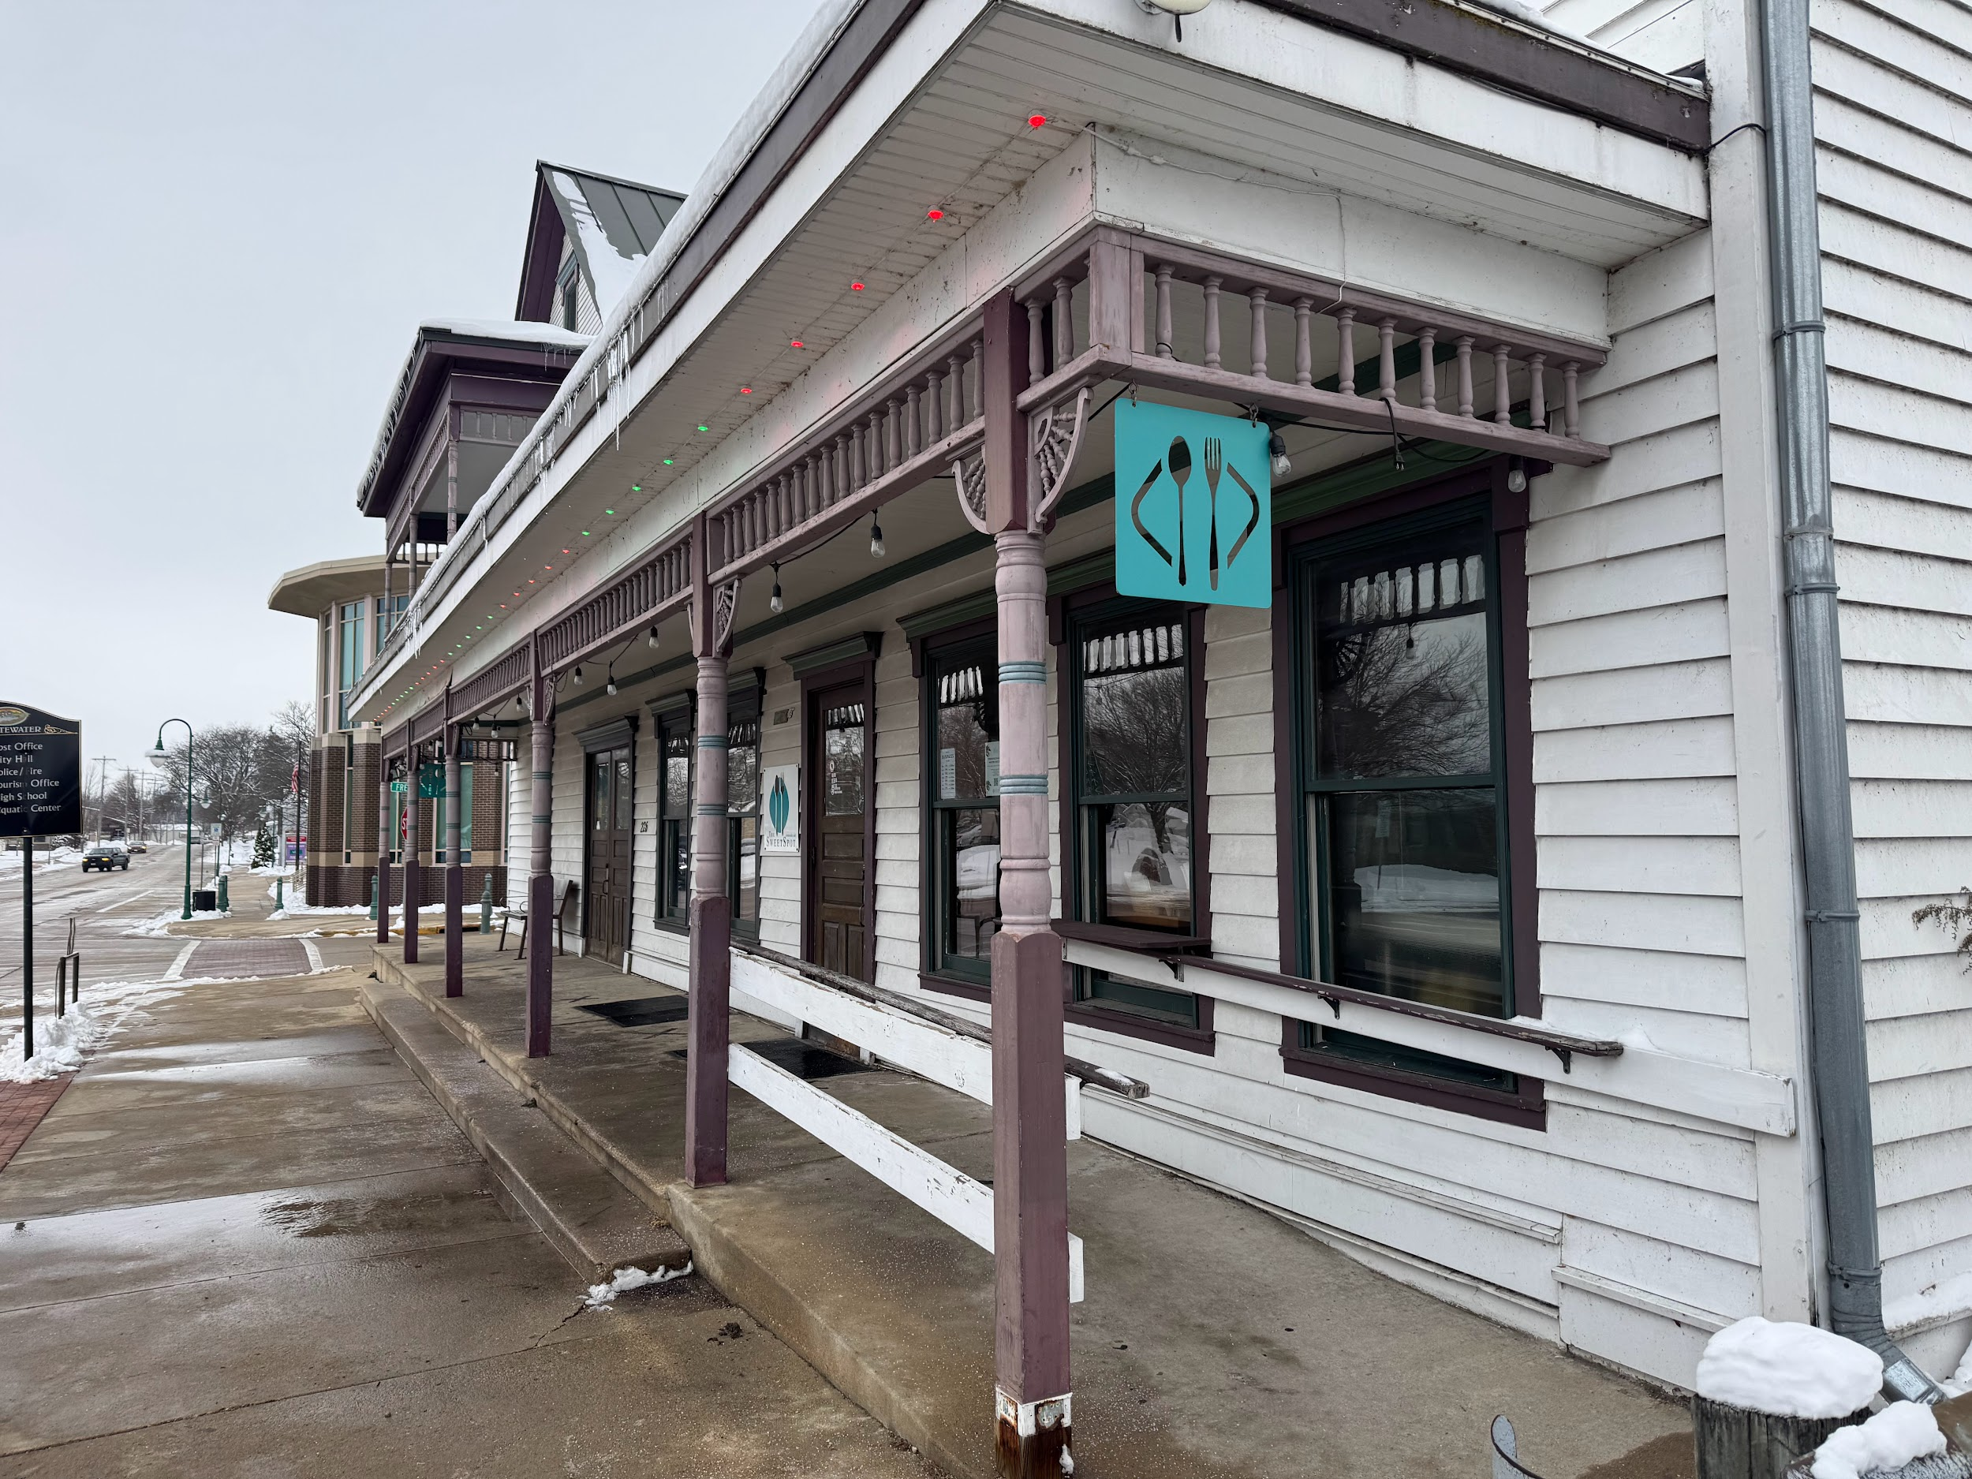

The remaining Sweet Spot located in the downtown district of Whitewater.

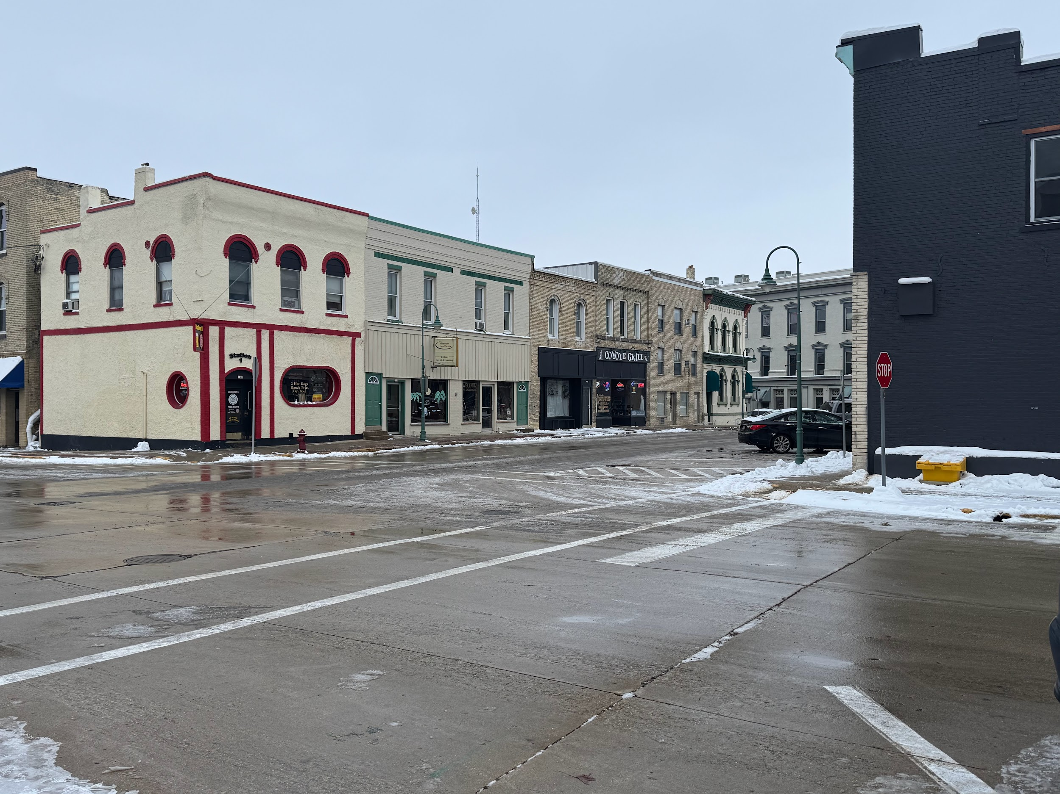

A closer look at the businesses in the heart of Downtown Whitewater.

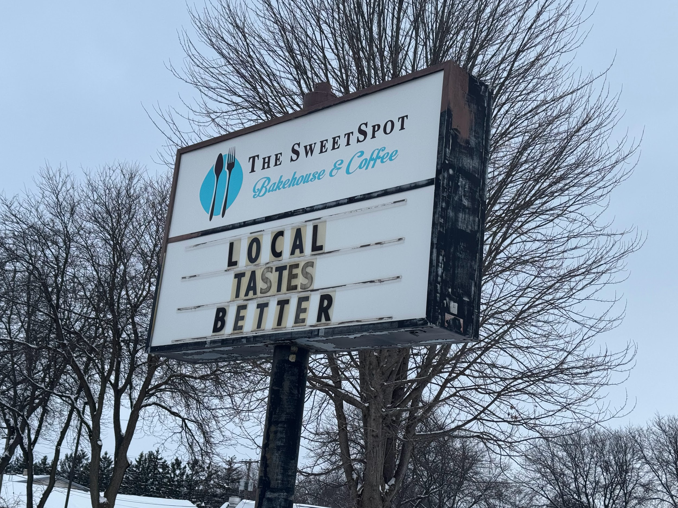

The sign of the recently closed Sweet Spot Bakehouse

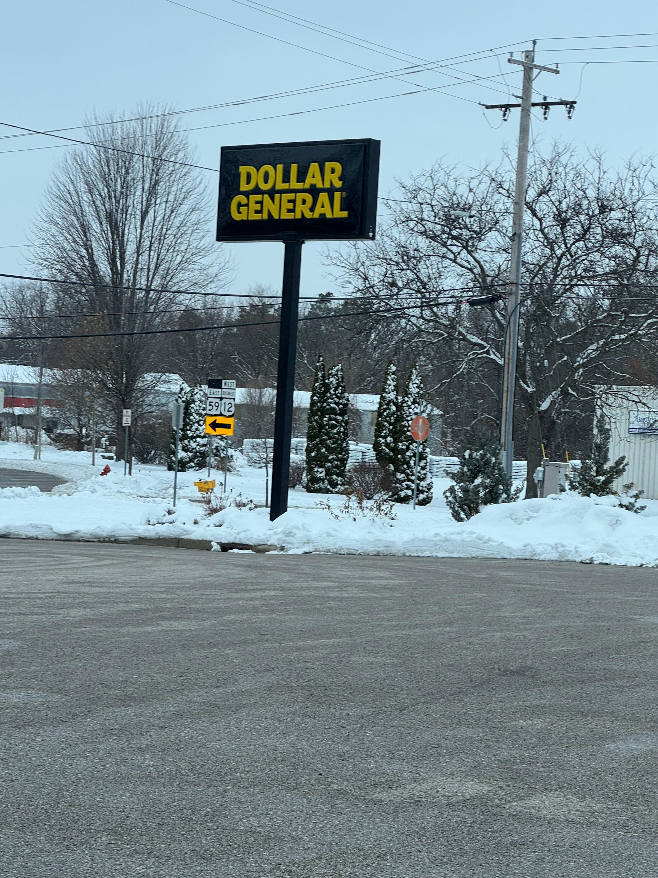

The sign of one of the more recent stores opened in Whitewater, Dollar General.

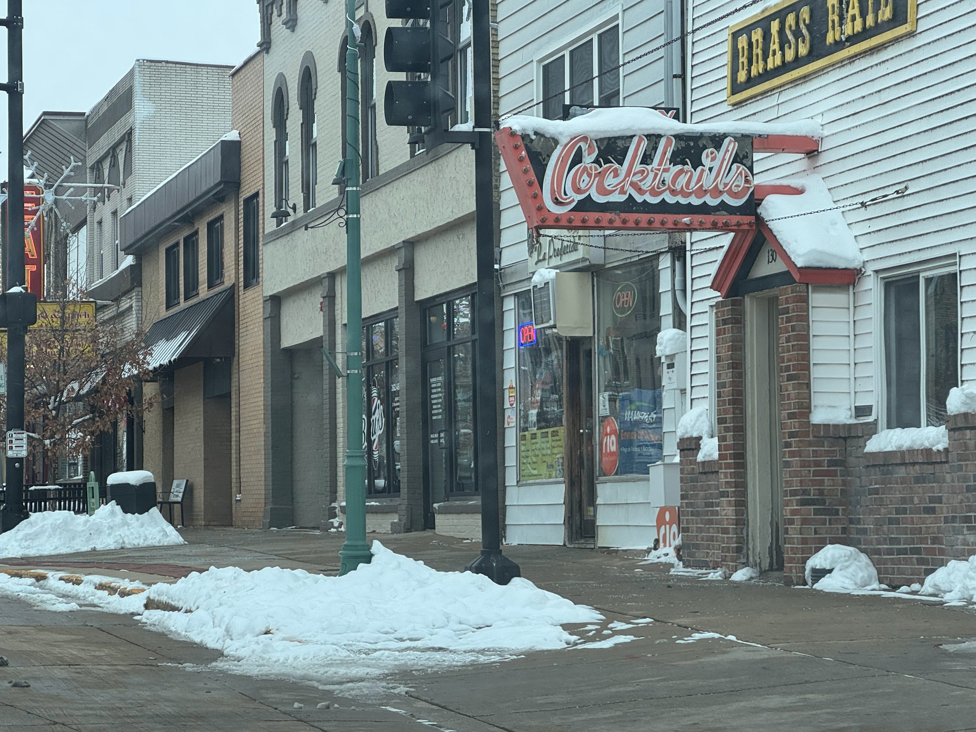

Old and New local businesses opened in the heart of Downtown Whitewater

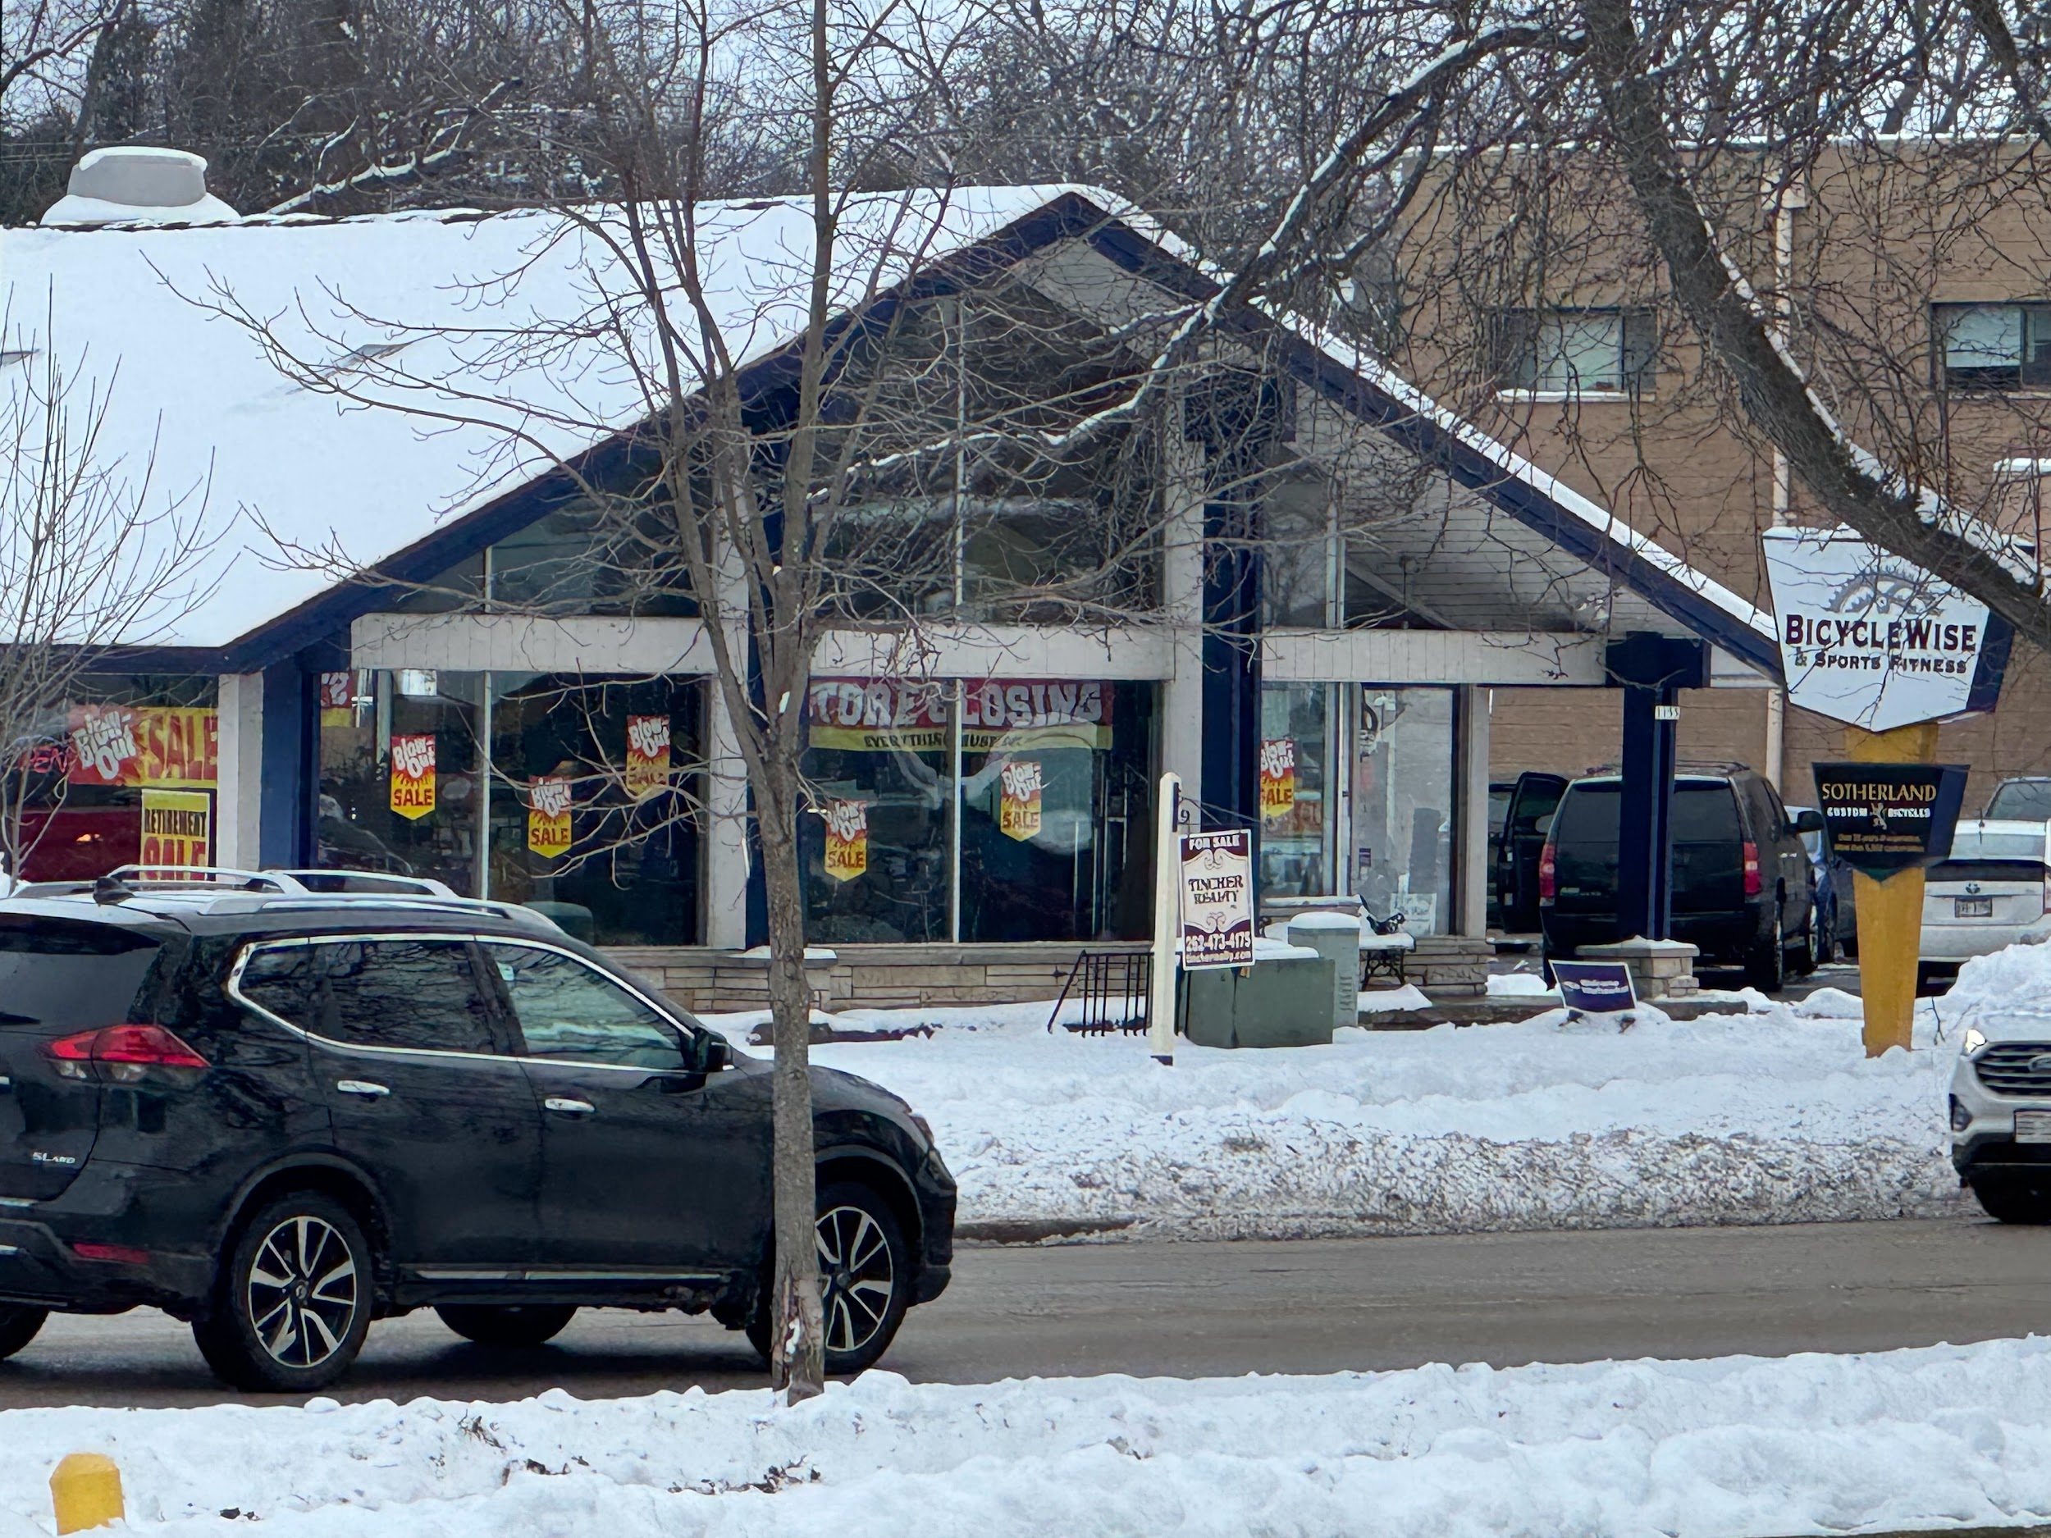

A closing sale of a long standing Whitewater business, Bicycle Wise.

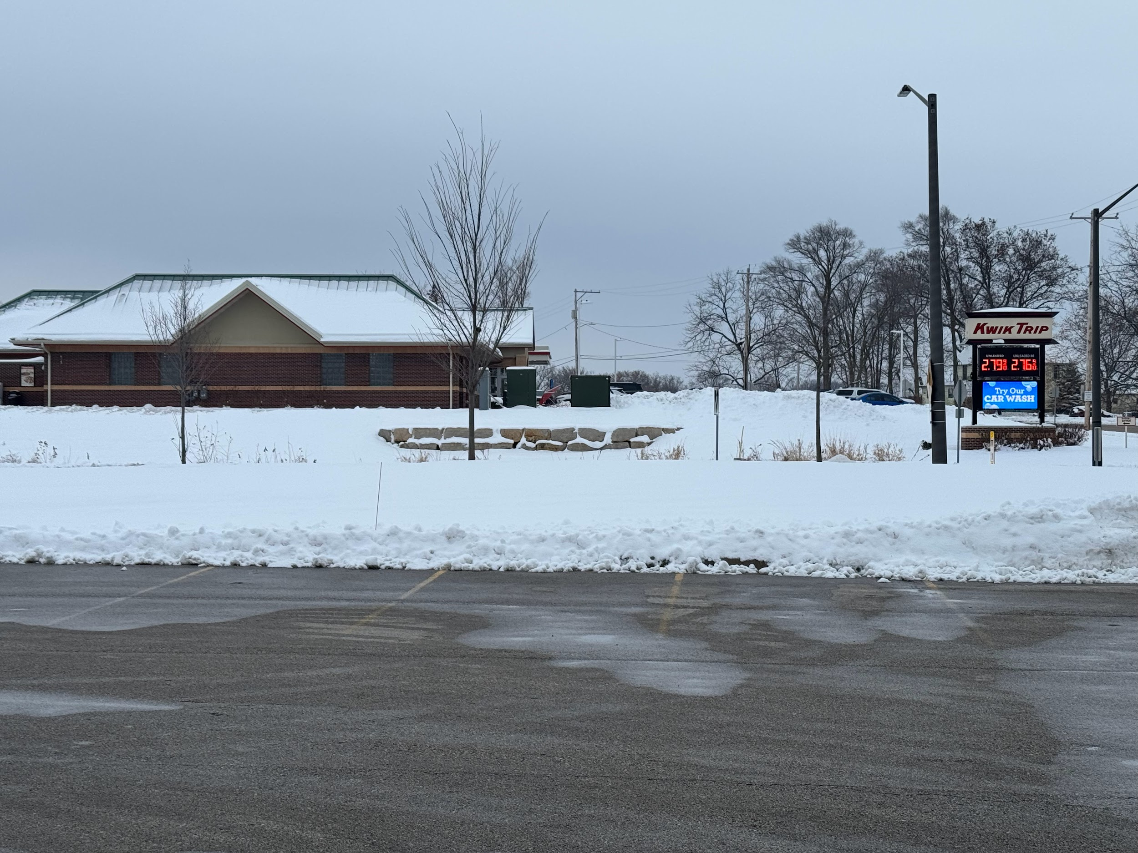

The more recent Gas Stations to build in the Whitewater community, Kwik Trip.

