UW-WHITEWATER/COMMUNITY AND

UW-W STUDENT OPTIMIST CLUBS

4th Annual TRiviA
night

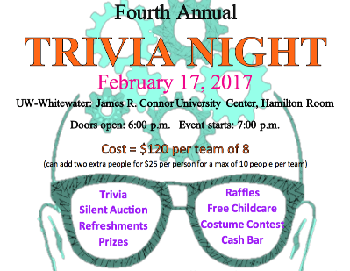

Whitewater Food Pantry Drive
Bring three items to donate for the Whitewater Food Pantry and
receive one ticket for an additional prize drawing!

Eligible Items
Canned Fruits ~ Canned Vegetables ~ Juice ~ Canned Chicken ~ Whole
Grain Foods ~ Sloppy Joe Mixes ~ Spaghetti Sauce ~ Soups ~ Condiments
~ Spices ~ Flour ~ Sugar ~ Powdered Milk ~ Healthy Snacks ~ Diapers ~ Packaged Meals ~ Toiletries ~ Dishes ~ Clothing ~ Napkins ~ Balloons ~ Candles ~ Birthday Cards ~ Cake Mixes ~ Frosting

Additional Items are Welcome!
Cash donations are
also welcome!

