Goat Yoga meets Wisconsin

If you thought Wisconsin was only good for beer and cheese, think again! Goat yoga is the new trend among small, farm towns in Wisconsin. This was an opportunity I just couldn’t miss!
With my two-year anniversary quickly approaching, I found myself searching the internet for something new and fun to do with my significant other. After a moderately long search, it seemed I was going to be stuck with the typical dinner and a movie.
I proceeded to click link after link until I found something interesting. I had stumbled upon a Facebook page dedicated to goat yoga. Well, I’m sure we all know what goats are and we should know what yoga is, but what is “goat yoga?
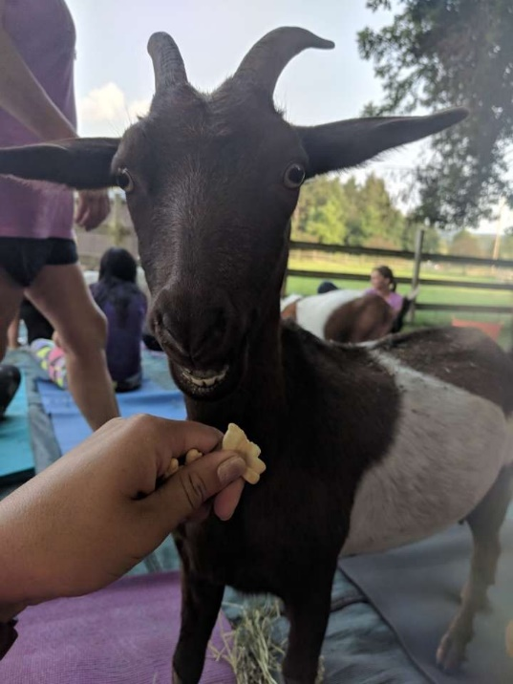
I started by reading a few posts and looking at pictures from the creators of the page, and I couldn’t stop smiling! I was not tricked; there were real goats happily playing around real humans doing yoga. Now this sounded like one heck of a date to me, and an affordable one at that.
As you can imagine, it didn’t take long to convince my girlfriend Alex that this would be a fun idea. “I can’t say I have ever heard of it,” she claimed, “but sign me up!”
Two days later we drove to a farm house in Sharon, Wisconsin. From the moment we got there I knew it we were in for an enjoyable night.
We played with 23 goats of all ages, shapes, and sizes. Claire Scott, the event planner, invited to feed and pet the goats at any time during our stay there. But that wasn’t even the best part!
Claire went on to preach, “Animals deserve a long life just like us and this is how we can do our part to make sure that happens.” We realized the five dollar fee asked of us went directly to the rescue of abandoned and mistreated animals in the Wisconsin area. So not only were we having a great time, we were contributing to a cause we can get behind!
Among playing with friendly goats, Alex and I met some great people who we may one day call our friends. The smiles and laughs we shared among one another were one of a kind. If you or anyone you know is interested in laughing, learning, and taking care of your body, check out this link to find an event near you! https://www.explorelacrosse.com/event/goat-yoga-at-rainbow-ridge-farms/

